

INDIAN INSTITUTE OF INFORMATION TECHNOLOGY ALLAHABAD

Subject – Data Mining and Warehousing

Topic – Deep Support Vector Data Description for Unsupervised and Semi-Supervised Anomaly Detection

Report By -

IIT2018108 – Ravi Kumar Sharma

Introduction :

Anomaly detection (AD) (Chandola et al., 2009; Pimentel
et al., 2014) is the task of identifying unusual samples in
data. This task lacks a supervised learning objective and
AD methods typically formulate an unsupervised problem to

find a “compact” description of the “normal” class, e.g. find-
ing a set of small measure that contains most of the data

as in one-class classification (Moya et al., 1993). Samples
that deviate from this description are deemed anomalous.

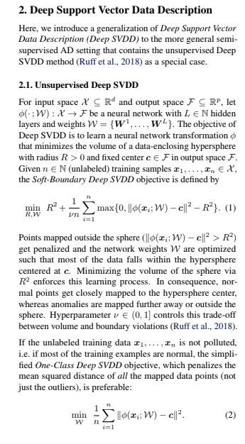

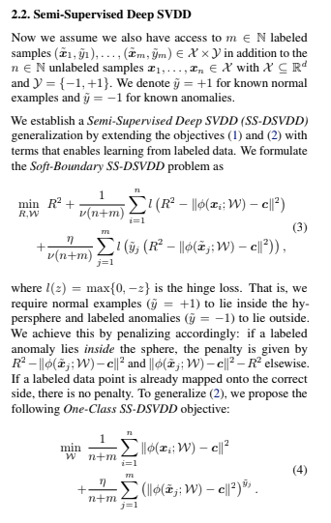

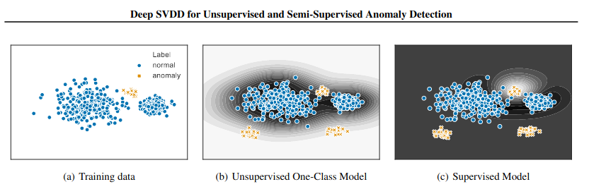

Conclusion :

We have generalized Deep SVDD to the more generalsemi-supervised setting in this work. The resulting Semi-Supervised Deep SVDD is an end-to-end deep method forsemi-supervised anomaly detection on high-dimensionaldata. We demonstrated experimentally, that SS-DSVDDsignificantly improves detection performance already withonly small amounts of labeled data. Our results suggest thatsemi-supervised approaches to AD should be preferred inapplications where some labeled information is available.

